The Sustainable Development Goals Barometer
December 2019
A measurable barometer for use in adjudication processes as part of design competitions and public procurement tenders involving architectural services
The sustainable development goals barometer is filled out by the bidding team in order to clarify the project’s profile pertaining to the sustainable development goals. Each goal in the barometer is graded on a scale of 0 to 5 (where 0 is the centre of the figure and signifies that the project does not address the specific goal) and should include a short text answering each of the 17 questions presented below. A total of 50 points must be distributed in the barometer. The result will show how the 17 goals relate to each other in the project, hereby giving an indication of the project’s total profile as to the sustainable developmental goals. This will be used in the adjudication process by the jury.

Example 1 Example 2

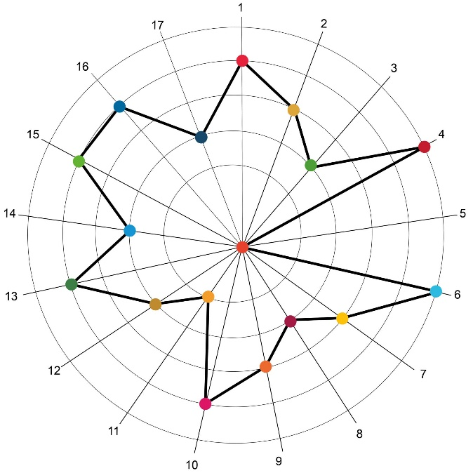
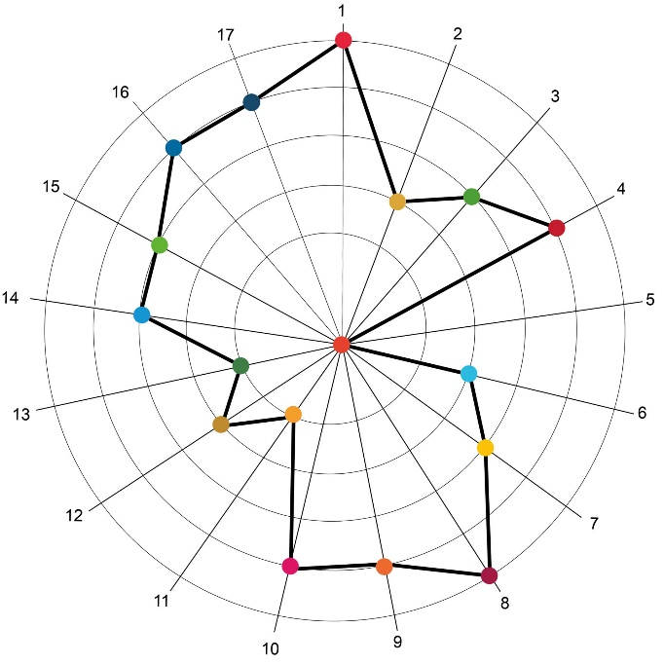

Since building and construction works may have very differing purposes, it is important to stress that it is also an option not to score some of the sustainable development goals.
Goal 1: End poverty; How and to what extent does the project address building with social awareness and create public and institutional spaces that provide equal access for everyone?
Description:_______________________________________________________Points: _____
Goal 2: End hunger; How and to what extent does the proposal address the protection of ecosystems and biodiversity, and how does it preserve areas for food production?
Description:_______________________________________________________Points: _____
Goal 3: Good health and well-being; How and to what extent does the proposal address security and health, including reduced exposure to communicable diseases and pollution, providing daylight, good acoustics and air quality as well as promoting healthy levels of activity?
Description:_______________________________________________________Points: _____
Goal 4: Quality education; How and to what extent does the proposal address inclusive educational environments?
Description:_______________________________________________________Points: _____
Goal 5: Gender equality; How and to what extent does the proposal address inclusion and equality between qualified persons, no matter their gender identity?
Description:_______________________________________________________Points: _____
Goal 6: Clean water and sanitation; How and to what extent does the proposal address the protection of groundwater resources and the risk of flooding, including how to avoid water waste and reducing the encroachment of saltwater on freshwater aquifers and bodies?
Description:_______________________________________________________Points: _____
Goal 7: Affordable and clean energy; How and to what extent does the proposal address the incorporation of renewable energy production in buildings and settlements designed for low energy use by adapting to local geographic, climatic and cultural conditions?
Description:_______________________________________________________Points: _____
Goal 8: Decent work and economic growth; How and to what extent does the proposal address that the building materials are produced in safe and clean environments, and ensure that there are fair and safe conditions in construction and demolition processes?
Description:_______________________________________________________Points: _____
Goal 9: Industry, innovation and infrastructure; How and to what extent does the proposal address services, products and systems that pollute less, use less energy, produce less waste and provide solutions that are safe, healthy and affordable?
Description:_______________________________________________________Points: _____
Goal 10: Reduced inequalities; How and to what extent does the planning and design approach of the proposal address social responsibility, inclusion and accommodating the needs of all people?
Description:_______________________________________________________Points: _____
Goal 11: Sustainable cities and communities; How and to what extent does the proposal promote measures that help to make cities more inclusive, safer, more resilient and adaptive to anticipated climate change with special attention to vulnerable segments of society?
Description:_______________________________________________________Points: _____
Goal 12: Responsible consumption and production; How and to what extent does the proposal address the use of durable and sustainable building components and materials favouring sustainable renovation and circular economy?
Description:_______________________________________________________Points: _____
Goal 13: Climate change; How and to what extent does the proposal address reducing climate-changing emissions associated with the construction and operation of the project including solutions adaptive to anticipated changes in climate?
Description:_______________________________________________________Points: _____
Goal 14: Life below water; How and to what extent does the proposal address special care for buildings and settlements in coastal regions and in fragile aquatic ecosystems, as well as ensure protection and support for animals and plants below water?
Description:_______________________________________________________Points: _____
Goal 15: Life on land; How and to what extent does the proposal address urban development that minimizes sprawl, reduces threats to biodiverse habitats and can integrate landscapes that provide habitat and connect with larger ecosystems?
Description:_______________________________________________________Points: _____
Goal 16: Peace, justice and strong institutions; How and to what extent does the proposal address democratic values, including the involvement of the citizens?
Description:_______________________________________________________Points: _____
Goal 17: Partnerships for the goals; How and to what extent does the proposal address cooperation within the building profession, with public and civic institutions and with fellow citizens in order to advance the goals?
Description:_______________________________________________________Points: _____
The questions are inspired by The UIA SDG Dhaka Declaration and the Manifest of the Danish Association of Construction Clients.

The barometer is freely available to the building and construction industry, and any use is not the responsibility of the Danish Association of Architects and the Danish Association of Construction Clients.

